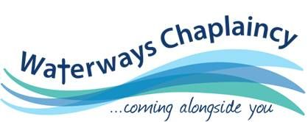

# Could YOU be a Waterways Chaplain?

Come and find out Wednesday 23rd January 2019 @ 9:30 am

## Wednesday 23rd January 2019

## 9:30 ‘till 16:00

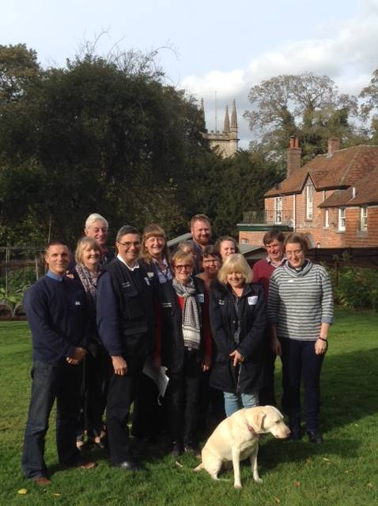

Please feel free to come and find out whether being a volunteer waterways chaplain is for you.

* You will find out what we stand for, who we help and how we aim to come alongside people on the towpath.
* You don’t have to have a boat just a desire to share God’s love to those you meet.
* There is no obligation to join if you attend.

*Find out more through our website: www.waterwayschaplaincy.org.uk*

### Newbury Baptist Church

### Cheap Street

### Newbury RG14 5DD

### Arrive from 9:30 for coffee

Bring your own lunch

Drinks provided

*www.waterwayschaplaincy.org.uk*

Please let us know if you are coming and how many as the event will only be held if we know you are coming!

Contact Babs Davis: 07792 108554

waterwaysbabs@hotmail.co.uk

