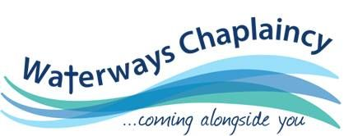

## *“Act justly, love mercy, walk humbly with your God.” Micah 6:8*

# Learn about Chaplaincy Essentials with the Waterways Chaplains

# W*ould you like to find out more?*

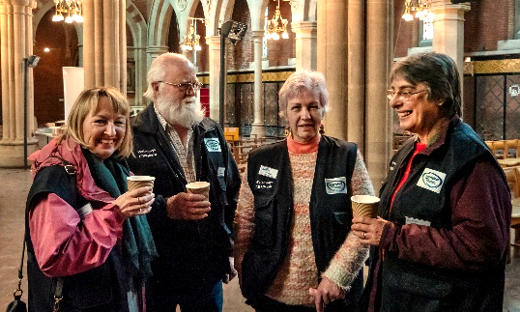

***Is God talking to you about a ministry out of the four walls of the church, being his feet, hands and voice in a very special community?***

**Come and find out Saturday**

**15th February 2020**

**January 2020 @ 9:30 am - free**

“We were so grateful for the day the Waterways Chaplain popped a card under our door. The Chaplain assisted with our immediate problems and stayed in touch with us until we were back on our feet.”

A boaters’ thanks

Please feel free to come and learn about chaplaincy and whether being part of a team of volunteer Waterways Chaplain is for you. The day will include consideration of:

* Chaplains as guest
* Knowing who you are
* The Chaplain and the church
* Listening and Caring
* Prophecy and Presence

The purpose of the training package is to help both WWC and/or anyone interested in the work to discern the nature of God’s call on their lives and also to establish a common basic skills level in WWC across the country.

### **VENUE:**

### **Willow Drive**

### **St Edwards Park**

### **Cheddleton**

### **ST13 7FG**

### **Arrive from 9:30 for coffee**

**Bring your own lunch**

**Drinks provided**

Please let me know how many will be attending as there are additional resources to send to attendees before they arrive. Please bring a bible, notebook, pencil and mobile phone.

This event is free but we are happy to receive a donation for costs.

Find out more through our website: **www.waterwayschaplaincy.org.uk**

Contact Lead Chaplain: [Barbara.davis@workplacematters.org.uk](mailto:Barbara.davis@workplacematters.org.uk) for full address and details.

