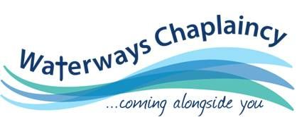

## *“Act justly, love mercy, walk humbly with your God.” Micah 6:8*

# Could YOU be a Waterways Chaplain?

# W*ould you like to find out more?*

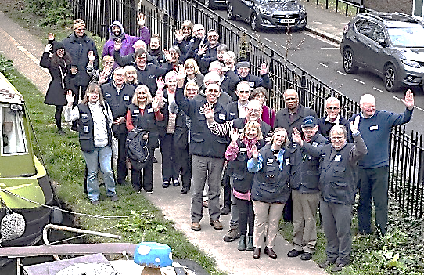

**Come and find out Tuesday 28th**

**January 2020 @ 9:30 am - free**

“We were so grateful for the day the Waterways Chaplain popped a card under our door. The Chaplain assisted with our immediate problems and stayed in touch with us until we were back on our feet.”

A boaters’ thanks

***Is God talking to you about a ministry out of the four walls of the church, being his feet, hands and voice in a very special community?***

Please feel free to come and find out whether being a volunteer waterways chaplain is for you.

* You will find out what we stand for, who we help and how we aim to come alongside people in God’s love on the towpath.
* You don’t have to have a boat or be ordained- just a desire to share God’s love to those you meet.
* Would you like to be part of a team?
* There is no obligation to join if you attend.

### **VENUE:**

### **Christ Church,**

### **18-28 Cross Street,**

### **Skipton**

### **BD23 2NF**

### **Arrive from 9:30 for coffee**

**Bring your own lunch**

**Drinks provided**

Please let us know if you are coming and how many as the event will only be held if we know you are coming!

**Find out more through our website: www.waterwayschaplaincy.org.uk**

Contact Lead Chaplain: Barbara.davis@workplacematters.org.uk

