LEAD WATERWAYS CHAPLAIN (NORTH)

Application Pack

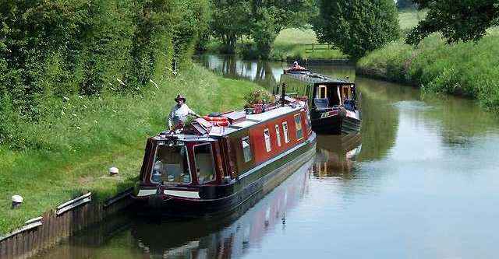

To be a catalyst in the waterways communities to bring about short and long term personal
transformation – emotionally, mentally and spiritually.

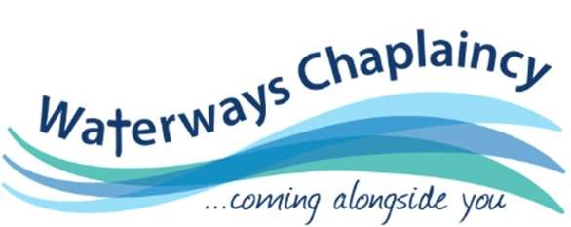

FROM THE CEO

I am delighted you are interested in joining the Waterways Chaplaincy team.

This is a really exciting time for Waterways Chaplaincy as it seeks to expand further in the north of England. Following the unexpected retirement on health grounds of the existing Lead Waterways Chaplain (North), there is an exciting opportunity to build on the excellent foundations she has laid. You would be working alongside Sarah Hayes, the Lead Waterways Chaplain (South) and led by Mark Chester, the National Senior Waterways Chaplain, You would be joining an impressive team of volunteers who are already making a life changing difference in the lives of those we meet.

Nationally, the aspiration is to grow the number of volunteers from the current 100 to 150 in the near future. The number of people using the waterways as their main home is growing, as are the needs. We regularly come across people facing issues of poverty, debt, mental health, isolation and eviction. This role enables many opportunities to be spiritually proactive and show God’s love through word and action in these areas of need and more widely across the north of England

We are therefore looking for an inspirational, experienced leader with initiative, creativity, passion and compassion to see this vision come to fruition. If this is you and you meet the criteria in the person specification, then we would love to hear from you.

Des Scott
CEO
Workplace Matters

WORKPLACE MATTERS AND THE CHURCH ARMY

Workplace Matters (WM) is an ecumenical Christian charity established in 2009. It seeks to demonstrate chaplaincy as a way of connecting the ministry of the church to the everyday needs and experiences of people. Waterways Chaplaincy is part of WM.
In 2017 WM formed a partnership with Church Army, an organisation with 140 years’ experience working with the homeless, marginalised and those in need. They bring expertise in support services such as HR, administration, compliance and leadership.
Waterways Chaplaincy is currently exploring ways of working with Church Army in the future

WATERWAYS CHAPLAINCY

Our Purpose
To enable people to encounter God’s love through inspiring and resourcing Chaplaincy and championing that work in the wider world.

Our Vision
To be a catalyst in the waterways communities to bring about short and long term personal transformation – emotionally, mentally and spiritually. Our Waterways Chaplains aim to support those who use the waterways and canals across the UK, but especially those who ‘live aboard’.

Our Values
To act justly, love mercy and walk humbly with our God, because God loves everyone and everyone is significant in his eyes. To support and encourage everyone, regardless of age, gender, race, sexuality, faith, ability or status.

BACKGROUND

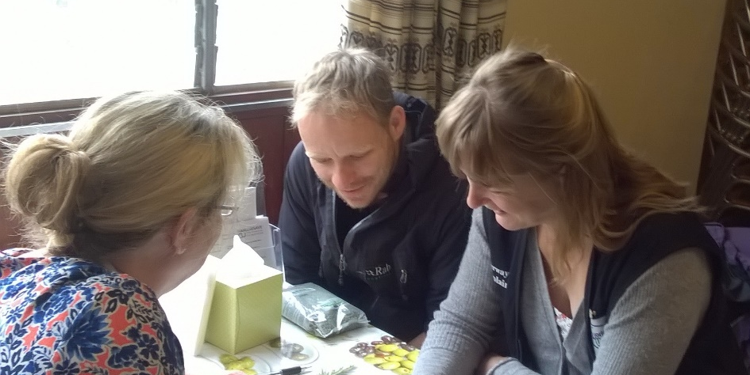
Waterways Chaplaincy (WWC) is a fast-growing initiative which made a ‘step change’ to a new regionally based structure in the North and South of England in 2019. In the last three years the number of volunteer chaplains has increased from 75 to over 100 and the intention is to have recruited a total of 150 in the near future.

The appointment of a Lead Waterways Chaplain (North) is crucial to this development in supporting the National Senior Waterways Chaplain in his national responsibilities and leading chaplaincy development.

The Waterways Chaplaincy’s (WWC) distinctive primary focus is to proactively reach out to people in our many and diverse waterways communities across the nation. The 2,000 miles of waterways and canals in England and Wales are busy! There are approximately 36,000 boats with the number of permanent live-aboards increasing by about 10% pa in addition to 4.2 million visitors to the waterways every fortnight. Chaplains also support the increasing number of boaters who are ‘signposted to them’ by the Canals and Rivers Trust (CRT) Welfare Officers and other boaters who are concerned for someone they have come across in need and other Waterways Chaplains. Rather like Street Pastors, Waterways Chaplains are there to serve those they come across. But unlike Street Pastors, our chaplains often help to sort out more involved issues with the boater e.g. seeking medical help, poverty and benefits problems. We see our relationship with the local Church as being of crucial importance.
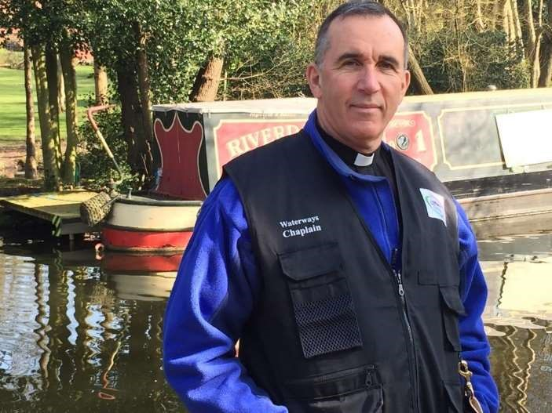
The project is led by a part-time paid National Senior Waterways Chaplain, Revd Mark Chester (left), who was recruited in March 2015. His activity has been a key part in growing the chaplaincy base and developing structure.

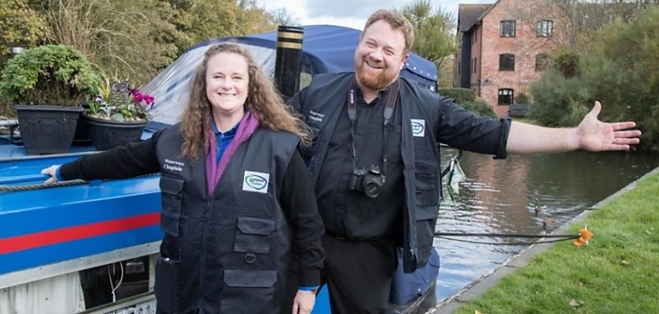

T

The social and economic context.
Newspaper headlines in the UK are often full of stories of the homeless on our streets, but rarely do you hear about the vulnerable and marginalised who are more hidden across our 2,000 miles of inland waterways and canals. As they silently travel through our communities, one could be forgiven for not even realising they had been there. Some of these boaters would not choose this way of living, but have had it thrust on them for economic and personal reasons e.g. redundancy, family breakdown, financial problems and mental health issues. These waterways users are in many ways the ‘hidden homeless’.

Living on the waterways might sound like an attractive way of life, but it can be isolating and when you need help, who can you turn to? It is complicated even more, by the requirement of those boaters, who have a ‘continuous cruiser licence’, to move on from their moorings every two weeks, which means they do not have their own postcode. Consequently simple daily activities like visiting the doctor, using foodbanks, obtaining benefits from the Department of Work and Pensions and even visiting family become a challenge. Without the normal framework of a local community and support services around them, they become invisible and seeking help becomes more fragmented. Their needs are then in danger of becoming more complex, costing more to local services. In short, the vulnerable are ‘falling through the net’ with no one to listen to or support them and in some cases this leads to feeling suicidal.

All WWC are Christians, called by God and motivated by their faith, who are committed to serving such people whether they are of Christian faith, other faiths or no faith.

All volunteer WWCs are members of a geographically defined WWC ‘hub’. In the north there are about forty WWCs located in hubs of varying sizes in the North West, North East, Lancashire, Staffordshire and North Midlands. There are a further six hubs in the South. Many, but not all, hubs have volunteer local Senior WWCs, who coordinate local ministries by providing mutual support and sharing of good practice through regular meetings. Hubs without Senior WWC are administered by Team leaders with fewer responsibilities. Hubs typically meet every 4-6 weeks and since Covid alternate between zoom and physical meetings depending on local circumstances.

This map shows the current location of WWC in England. The red line indicates the approximate boundary between the North and South WWC regions.

A volunteer WWC’s role is to walk the tow paths, in pairs where possible, within a certain geographical patch, although some with their own narrowboats exercise a ‘roving’ ministry as they move areas. They are all trained volunteers, who are assigned a mentor for the first few months and are from different backgrounds e.g. retired mental health professionals, engineers and police officers! The chaplains are very connected into their local communities and aim to both respond to referrals and proactively ‘come alongside’ boaters in need, especially those with personal challenges.

The chaplains offer help in:
- Listening: listening ear to the isolated.
- Signposting: sign post those in difficulty to local support services e.g. Foodbanks.
- Advocacy: act as advocates when a boater needs someone to unravel issues e.g. benefits problems.
- Emergencies: taking boaters to access emergency medical support e.g. Doctor or hospital. Access to a WWC ‘Hardship Fund’.
- Practical ways e.g. washing and drying laundry for boaters after capsizing.

It is the role of the Lead Chaplain to facilitate all of the above.

JOB DESCRIPTION

Job Title: | Lead Waterway Chaplain (North)
Location: | Home-based (North of England)
Responsible To: | National Senior Waterways Chaplain (Nat Sen WWC)
Responsible For: | Volunteer Chaplains Northern England and Northern Wales
Purpose: | To support the Nat Sen WWC by providing effective operational leadership for WWC in Northern England and Northern Wales
Objectives: | - To be a member of the WWC leadership team  - To expand and develop an effective WWC service in Northern England and Northern Wales  - To recruit, train and oversee the volunteer chaplains

Key Tasks:

- To be a member of the WWC leadership team
  - To work with the National Senior Waterways Chaplain (Nat Sen WWC) to achieve strategic development for the waterways chaplaincy with particular responsibility for operational implementation.
  - To work in conjunction with the Nat Sen WWC to develop training that ensure continuous development of volunteer teams.
  - Deputise for the Nat Sen WWC when so requested.
  - Liaise with Lead WWC (South) on issues of common interest eg centralised zoom based training.

- To expand and develop an effective waterways chaplaincy service in Northern England and Northern Wales
- Create new opportunities for WWC development.
- Liaise at regional level with local agencies such as Canals and Rivers Trust, Department for Work and Pensions and various boaters groups to establish effective relationships within each to facilitate positive outcomes when there are issues that require resolution.
- To build up networks with local Churches.
- To liaise and connect with other regional organisations doing similar work.
- Ensure that reports, and all other information, from volunteer chaplain groups are forwarded to the Workplace Matters central office for funding and management purposes. Most of the feedback will be through the WWC website.

- To recruit, train and oversee the volunteer chaplains
  - Recruit, train and support a growing team of chaplaincy volunteers in conjunction with the national plan and strategy.
  - Recruit, train and support local WWC Team Leaders in consultation with Sen WWCs.
  - Support, oversee & direct volunteer chaplains with their day to day issues usually through their Sen WWC. This may include the ability to respond quickly to urgent requests for support from WWC often received via the WWC website.
  - To liaise with the administration team to make sure all the relevant checks especially DBS and safeguarding are done for volunteers.
  - To undertake regular reviews with the volunteers.
  - To ensure good practice across all areas, including Safeguarding and Health & Safety.
  - Be a ‘chaplain to the chaplains’ especially Sen WWC, Team Leaders and exceptionally to individual volunteer WWC.
.

General
  - To be the regional public face of WWC. To be an advocate for Waterways Chaplaincy identifying and taking opportunities to publicise the ministry.
  - To adhere to the policies and procedures of WWC at all times and ensure that the volunteers are aware and acting in accordance of them.
  - To attend regular supervision and annual reviews with the Nat Sen WWC and attend any training as deemed necessary for the performance of the role.
  - Any other tasks appropriate to the role that may be assigned by the Nat Sen WWC or CEO.
  - To act in the best interest of the Waterways at all times.

Pattern of Work

As an indication of what might be expected in this role, a typical working month might include the following activities recognising that the work is episodic with peaks and troughs depending largely on the seasons

- Run a training day for Probationary WWC (‘WWC Familiarisation’ or ‘Chaplaincy Essentials’).
- Attend a Regional WWC ‘Hub’ meeting run by a Sen WWC in person or zoom.
- A support meeting with your senior Chaplains and/or Team Leaders.
- Commission or Relicense a WWC in a local church which might include preaching. This involves being away from your local Church.
- Input to National WWC agenda & monthly ‘WWC Headline’ for regional Hub meetings.
- Write an article or be interviewed for local Christian or secular press.
- Give a presentation on WWC to interested groups.
- Engage with and maintain a list of potential WWC’s, contacting & facilitating new enquiries about WWC. This includes liaising with Church Army HR, follow up of applications, DBS, references.
- Meet or zoom with Nat Sen WWC.
- Meet and/ foster good relationships with local waterways authorities eg CRT licensing Supervisors.
- Respond to urgent requests for support from volunteer WWC.
- Walk the towpath with a WWC to gain situational awareness.
- Conduct a121 as a prior requirement to relicensing a volunteer WWC.
- Work on agreed ‘special project’ responsibilities within the Chaplaincy eg IT related Issues, prayer, communications etc.

A typical working year might include:

- Attending a three-day Sen WWC conference in Sheffield.
- Attending a one-day spring ‘catch up’ conference in Sheffield.
- Leading a ‘local mission’ or display stand at a Christian event for the purpose of WWC recruiting.
- Input to a National WWC ‘celebration’.
- Being responsible for the administration of a regional WWC training day.
- Interviewing all WWC as they seek to renew their licenses every three years.

PERSON SPECIFICATION

The following sets out what we are looking for in the post holder. As you apply for the post and submit your application, please make sure you evidence with good clear examples how you meet the criteria below. These should be evidenced through your application, and then if applicable through your interview and references.

 | Essential
Experienced in spiritual leadership in church or voluntary sector (ideally 5 years or more). This experience can be in a lay or ordained capacity | Application, reference and interview
Spiritually, emotionally and mentally robust. | Application, reference and interview
Evidence of an ability to be accountable and seek advice when appropriate. | Reference
Resilient. Able to work in isolation, responding appropriately to pressure and criticism. | Application and reference
Able to take initiatives, be creative and ‘seize the moment’. | Interview
The ability to operate without clearly defined objectives and outcomes, to accommodate competing priorities. | Application and interview
Good organisational and delegation skills, able to deliver on time and within budget | Application and interview
Administratively competent at operational level. | Application and interview
Excellent communication skills – specifically listening, questioning, giving feedback, building a rapport and giving a presentation. | Interview
Good time management skills. | Interview
Understanding confidentiality and how it applies in this context | Application and interview
An ability to work within and inspire a team | Application form
Proven ability to work ecumenically | Reference and Application
Knowledge of Christian values and theology as applied to the waterways ministry | Interview
Knowledge of the purpose, vision and values of  Waterways Chaplaincy | Interview
An ability to work with people across a wide diversity of backgrounds , cultures and circumstances | Application and Interview
Ability to share their faith appropriately in different contexts | Interview
Reasonably fit and active | Interview
Able and willing to travel to locations, as appropriate | Interview & application
Competent IT User | Interview

Prior experience in chaplaincy; on the waterways; with the homeless; or social welfare provision e.g. CAB, CAP, is desirable.

OUTLINE TERMS AND CONDITIONS

Salary | £18,713.88
Location | Home-Based
Hours | 20 hours per week worked flexibly over the week
Annual Leave | 25 days plus bank holidays (pro rata)
Pension | You will be assessed under pension auto enrolment and if eligible enrolled into a qualifying scheme where pension contributions will be deducted from you and made for you by the employer at the legal minimum levels. If you choose to contribute 6% into the scheme, Workplace Matters will match this.  Pension legislation and scheme rules apply.
DBS | Enhanced
Notice Period | Three Months, after successful completion of probation
Probation Period | Nine Months
Occupational  Requirement | It is an occupational requirement that the job holder is a Christian under Part 1 of Schedule 9 to the Equality Act 2010. This means that the post holder is agreement with our vision and values, and is actively engage in the life and ministry of a church.
Expenses | Reasonable expenses will be reimbursed monthly in accordance with WM policy.

APPLICATION PROCESS

To apply, please submit an application form which is available to download from the Waterways Chaplaincy website www.waterwayschaplaincy.org.uk

Deadline: Sunday 10th July
Interview date: Tuesday 26th July in Sheffield

Applications should be sent to hr@workplacematters.org.uk

Offers of employment are made subject to:
- Evidence of your eligibility to work in the UK
- An enhanced DBS check
- Successful completion of a nine month probationary period
- Two satisfactory references (one from your Church Leader plus one other)

References will only be taken up once we have asked you expressly for your permission to be given.

For details of how we handle your data as part of the recruitment process, please see our Recruitment Privacy Notice

